Weekly Progress Report – Week 2

Project Name: Heart Disease Visualisation

Date: 3rd February, 2025

Team Members: Nicole, Collins, Emmanuella, Prince

1. Overview of Week 2 Progress
A summary of the progress made during the second week of the project.
This week, we focused on refining our dataset and visualizations. Key tasks completed:
- Searched for additional data on age-standardized mortality, incidence, and prevalence rates since they were not included in our original dataset from the Global Burden of Diseases (GBD) data.
- Created the required plots as specified in the deliverables.
- Implemented the initial layout for the Dash dashboard to visualize our findings.

2. Individual Contributions
Each team member should detail their progress and challenges faced during the week.

A. [Nicole]
- Progress Made:
  - Cleaned up some later detected merging issues with the final dataset
  - Implemented appropriate visualizations for the risk factor correlation analysis
  - Designed a high fidelity wireframe for the dashboard
  - Implemented the base layout code for the dashboard
  - Implemented the risk factor analysis page for the dashboard

- Challenges Faced:
  - Detected multiple different values for heart disease rates per country due to merging errors.
    - Solution: Found and tackled the root of the issue and re-merged the datasets.
  - Deciding what plots/items to display on the overview page for the dashboard.
    - Solution: Researching and drawing inspiration from similar dashboard overview pages.
  - Making the app responsive in a mobile viewport
    - Solution: Experimented with dash_bootstrap_components and style settings to solve the issue.

B. [Collins]
- Progress Made:
  - Retrieved additional data on age-standardized mortality, incidence, and prevalence rates from Global Burden of Diseases (GBD).
  - Created time series plots for mortality rates.
  - Developed additional plots related to mortality rates.
  - Wrote code to implement the Mortality Plot page on the initial Dash dashboard layout.
  - Compiled individual reports from team members into a final document.

- Challenges Faced:
  - Finding the best imputation method for filling missing values between 1960 and 1980. Solution: Settled on Polynomial fitting, using Gender, Country, and Age Group as learning parameters.
  - High loading time for initial visualization plots. Solution: Optimized by breaking visualization codes into functions to improve efficiency

C. [Emmanuella]
Progress Made:
- Developed the code for the choropleth map, integrating year and continent filters to allow users to dynamically explore heart disease data.
- Used the Gapminder dataset to supplement the imputation of null values in the original dataset. This approach helped ensure more accurate visualizations and analysis.
- Made several changes to my script to optimize the visualization and ensure that the map displays the most up-to-date and complete data.
Challenges Faced:
- Managing missing data: Some datasets had significant missing values, which required careful imputation. The Gapminder dataset provided a helpful reference, but integrating it smoothly into the existing code was challenging.
- Solution: I refined the imputation method to better handle missing values across different regions and time periods.

D. [Prince]
- Progress Made:
  - Implemented risk factor correlation plots
  - Designed low and high fidelity designs in figma
  - Implemented overview page in dash

- Challenges Faced:
  - Difficulty in selecting suitable designs for the dash overview page.
    - Consulted team members for design ideas
  - Inability to render selected plots in dash, especially with dbc cards
    - Resorted to tutorials on how to render plots in dash. My unfamiliarity with the framework is a key reason for this challenge.

3. Screenshots & Visual Evidence
Notebook Visualizations
- Global Mortality Rate over Time
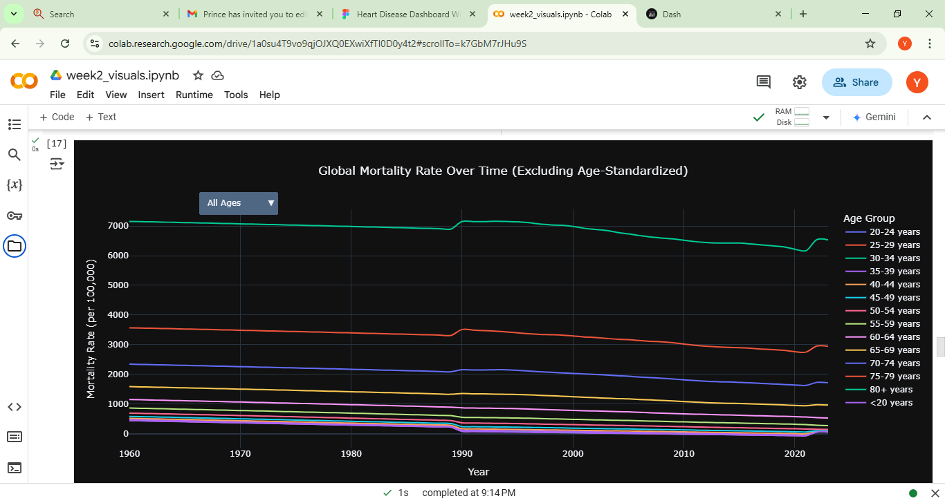
- [Age Standardized Mortality Rate by Country]
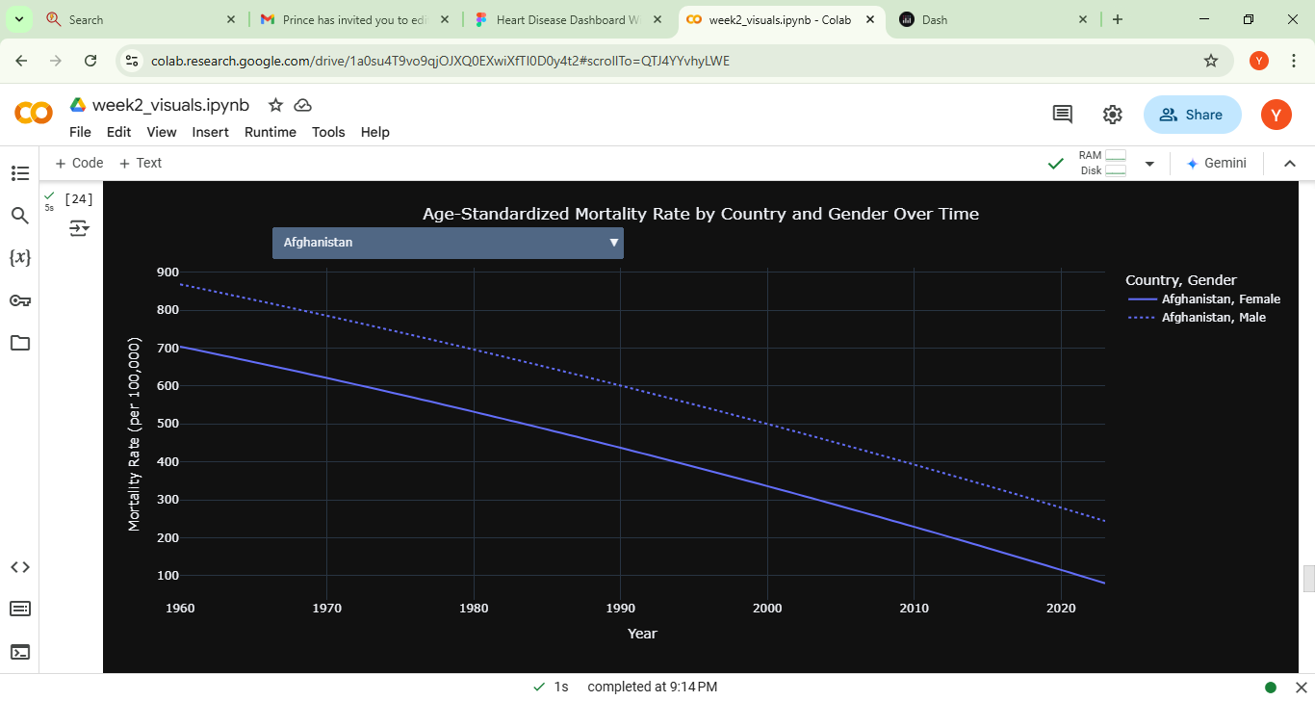
- [Avg Mortality Rate per Country]
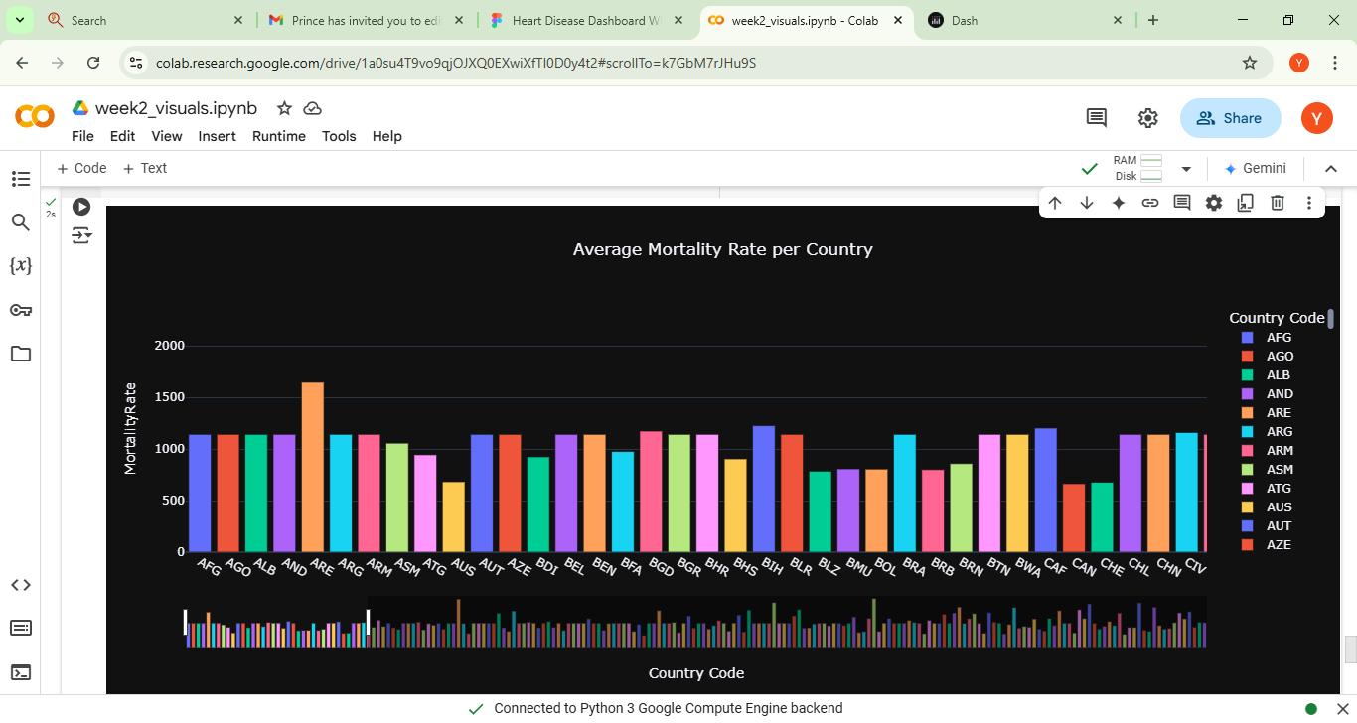
- Correlation Matrix Heatmap (Risk Factors)
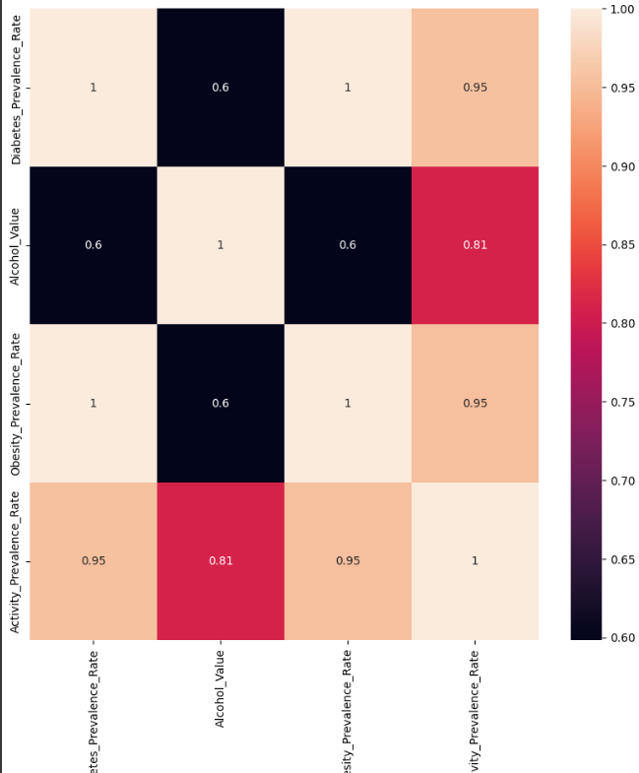
- Correlation Matrix Heatmap (plus Prevalence/Mortality/Incidence Rates)
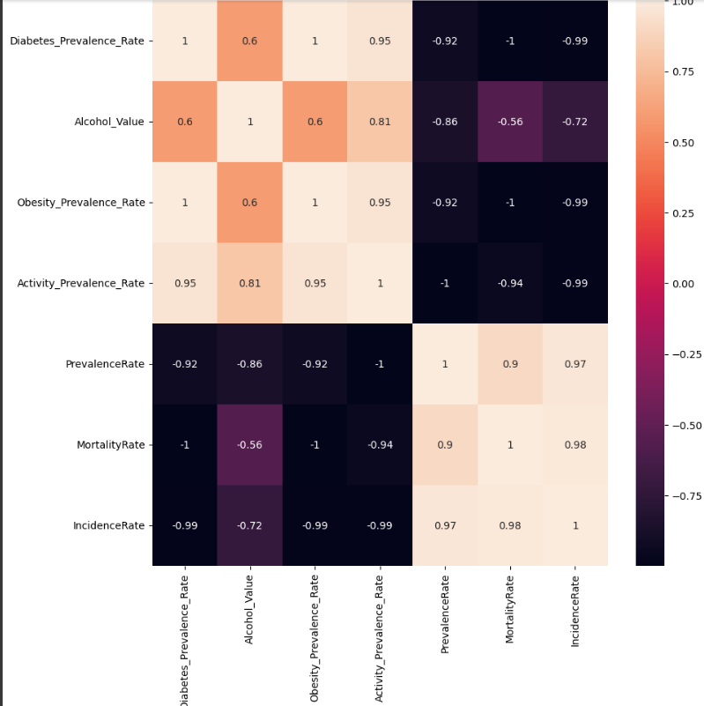
Wireframe
Low fidelity
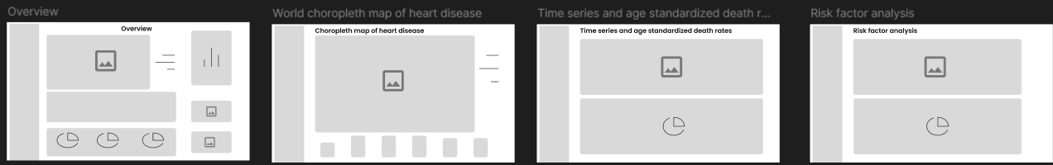
High fidelity
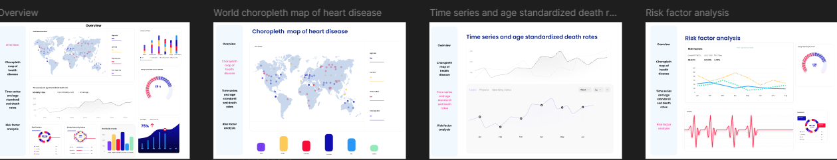
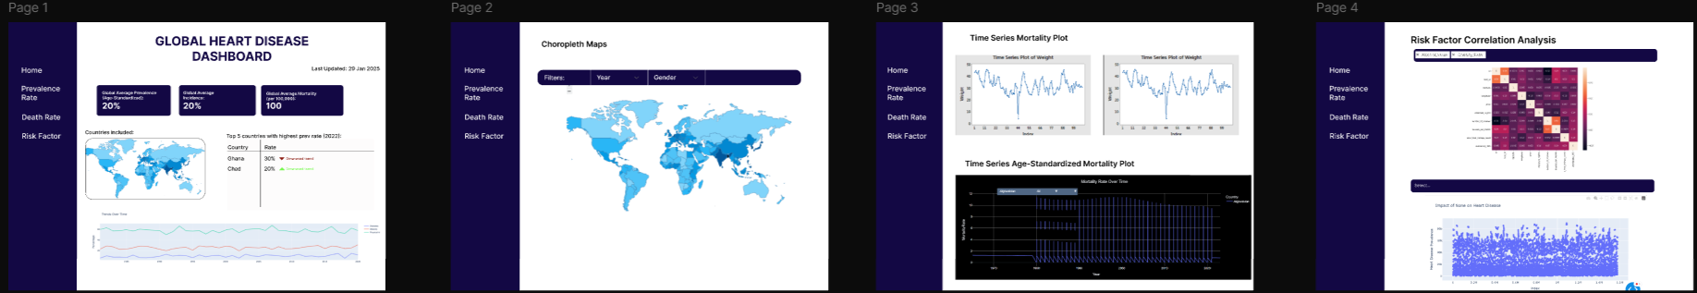
Dashboard
- Overview Page
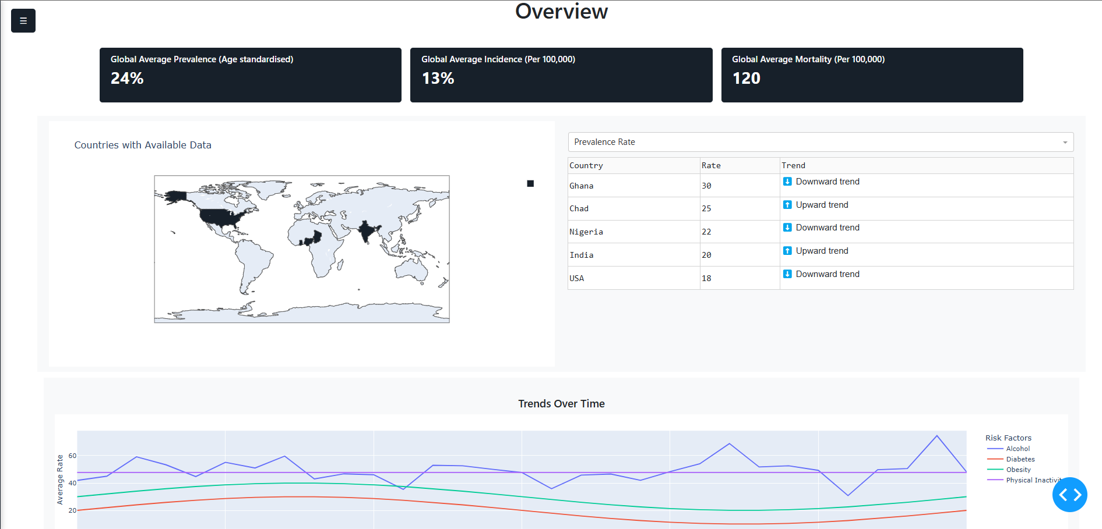
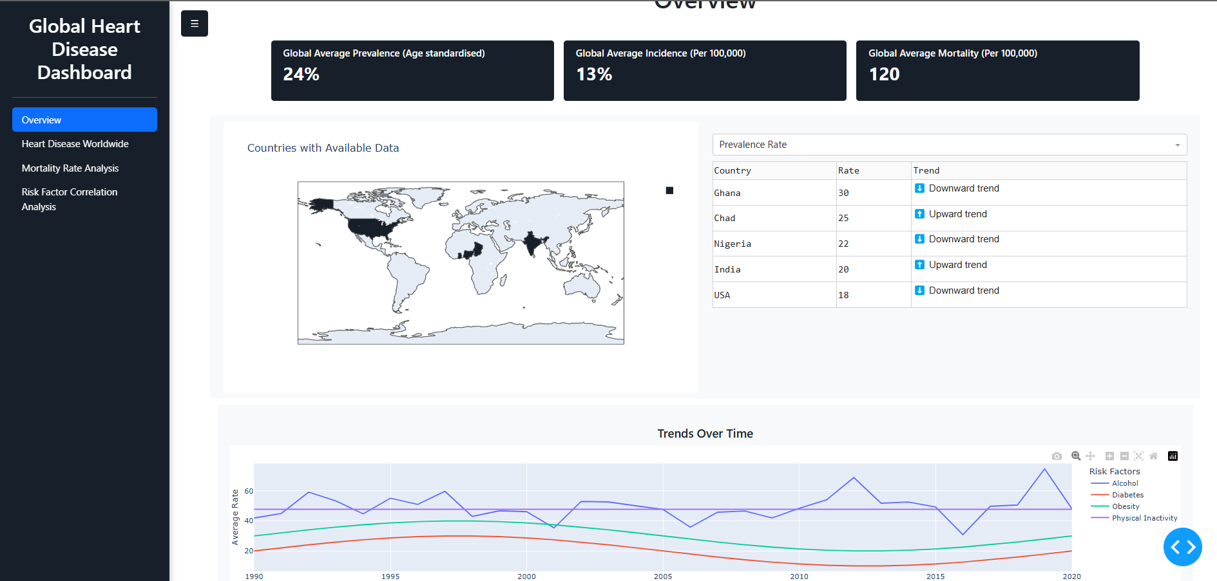
- Heart Disease Worldwide Page

- 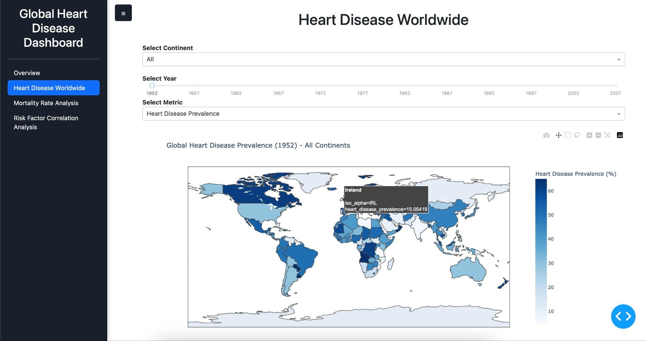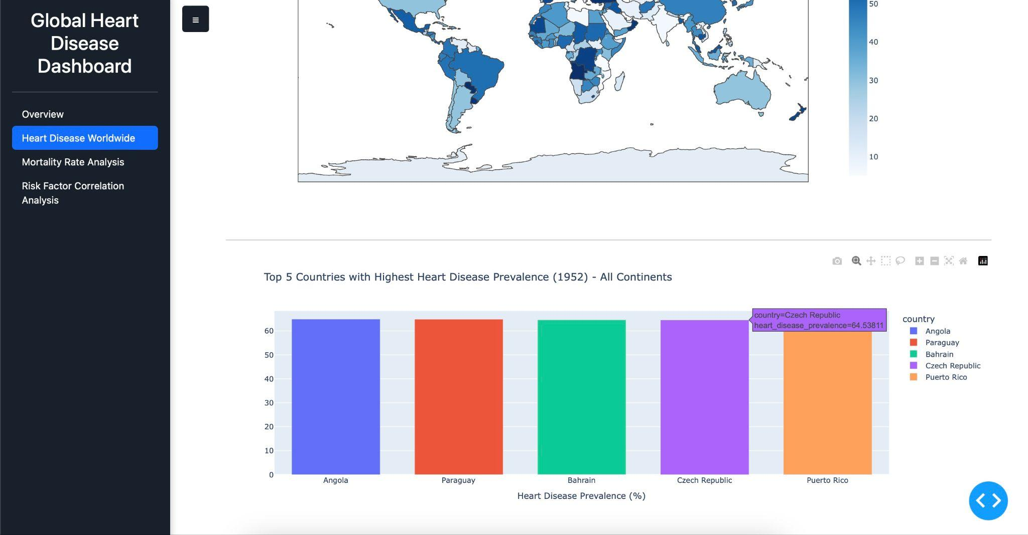

- Mortality Rate Analysis Page

- Risk Factor Correlation Analysis Page
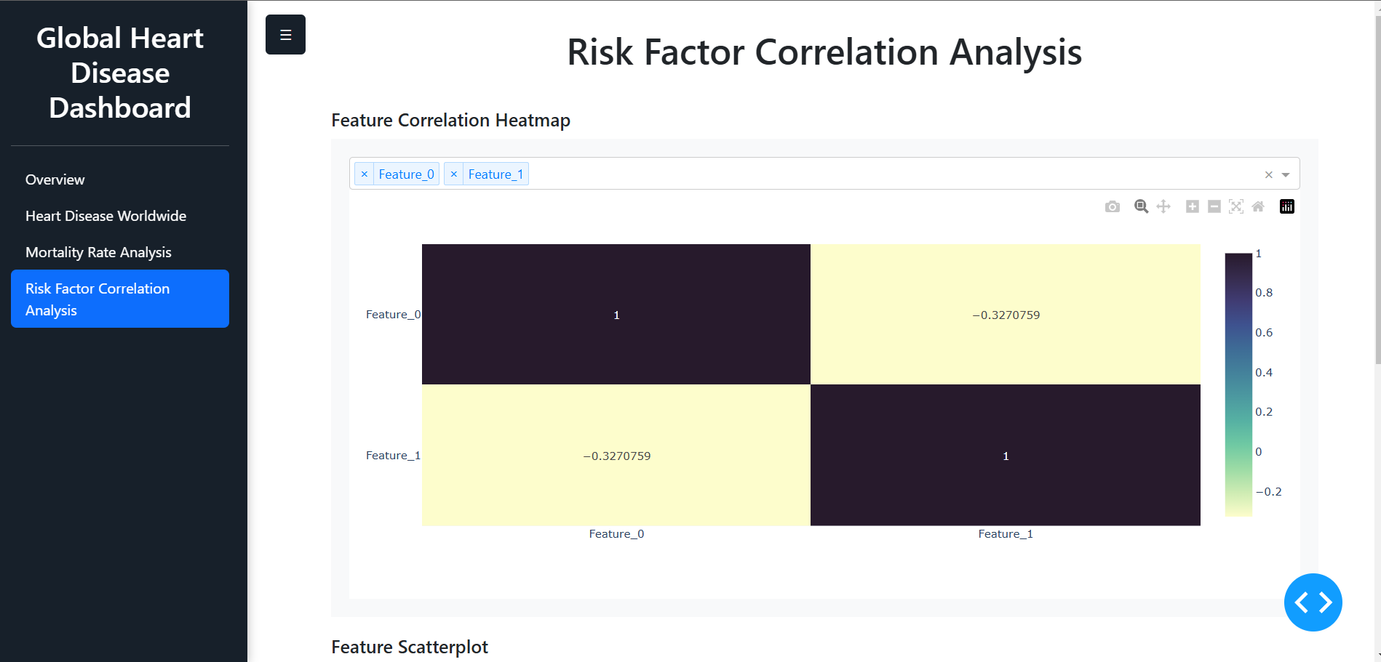
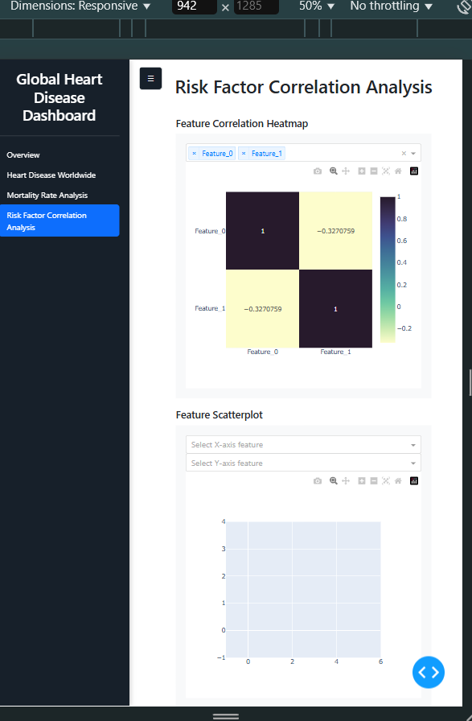

4. Key Insights & Next Steps
- Key Insights: We learned how to optimize visualization performance by structuring code efficiently—breaking down complex visualizations into functions significantly reduced loading times. Furthermore, integrating interactive elements like filters into the visualizations to be further implemented in the Dash dashboard helped enhance user experience. These lessons reinforced the importance of efficient data handling, performance optimization, and interactivity in data-driven applications.

- Main Next Steps:
  - Implement Interactive Features
  - Create Advanced Visualizations

